ASSIGNMENT 2

1. Build a python code, Assume u get temperature and humidity values (generated with random function to a variable) and write a condition to continuously detect alarm in case of high temperature.

# PROGRAM:

import random temprature=random.sample(range(30,50),1) print("Temprature is",temprature) if(temprature>=[46]):

print("High Temprature") print("Alarm is on")

else:

print("Temprature is Normal") humidity=random.sample(range(30,50),1) print("Humidity is",humidity) if(humidity>=[50]):

print("Humidity level is High") else:

print("Humidity level is Low") soil_moisture=random.sample(range(30,60),1) print("Soil Moisture is",soil_moisture) if(soil_moisture>=[50]):

print("Soil Moisture level is Normal") else:

print("Soil Moisture level is Low") print("Water Pump is on")

# SCREENSHOTS:

* **CODE:**

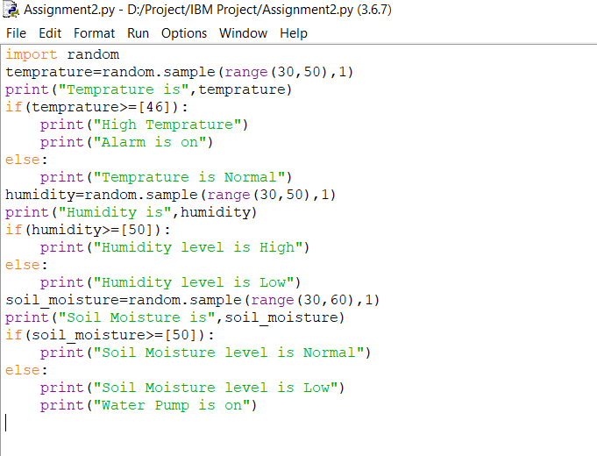

**OUTPUT:**

